

STUDENT NAME: CAROLINE MATHEMBO MUSYOKA
ADM NUMBER : BSCCS/2024/74753
COURSE : COMPUTER SCIENCE
UNIT CODE : BIT 3208
UNIT NAME : ADVANCED WEB DESIGN AND DEVELOPMENT
LECTURER NAME : NYORO MICHAEL
SEMESTER : MAY/AUGUST 2026
PROJECT TITLE : E-COMMERCE
SELECTED TECHNOLOGIES : PHP+MYSQL
GITHUB LINK: https://github.com/mathembocarol6-jpg/BIT3208.git

Contents
WEEK 1: LOCALHOST TESTING AND DATABASE CONNECTIVITY TESTING 3
1. INSTALLED LOCALHOST 3
Figure 1.0: XAMPP control panel 3
2. LOCALHOST TESTED SUCCESSFULLY 3
Figure 1.1: http://localhost/phpmyadmin/ 3
3. HELLO WORLD PAGE 3
Figure 1.2: HELLO WORLD Test page 3
4. BASIC DATABASE CONNECTIVITY 3
Figure 1.3.0: sample database 3
Figure 1.3.1: database connection string 3
Figure 1.3.2: successful database connection 3
WEEK 2: UI/UX AND DESIGN FOUNDATIONS 3
1. DESIGNED WIREFRAMES 3
Figure 2.0: canva design of the login page 3
2. DESIGNED GUI CONCEPTS 3
Figure 2.1: GUI design 3
3. SELECTED PROJECT THEME 3
4. CHOSEN TECHNOLOGY 3
WEEK 3: FRONTEND AND BACKEND PROGRAMMING FOUNDATION 4
1. JavaScript Basics 4
a) implemented JavaScript Basics 4
Figure 3.2: Created Form Validation 7
2. DOM Manipulation 7
Figure 3.3: successful DOM Manipulation 7
3. Introduction to PHP 7
Figure 3.4: Tested PHP Syntax 7
4. Database Connection 7
Figure 3.5: Successful Database Connection 7
WEEK 4: DYNAMIC BACKEND PROCESSING AND REAL USER INTERACTION SYSTEMS 7
1. Login form 7
Figure 4.0: login form 7
2. Form validation 8
Figure 4.1: form validator 8
3. PHP processing 9
Figure 4.2: user authentication processing 9
4. Folder structure 9
Figure 4.3: folder 9
WEEK 5: BUILDING DATA-DRIVEN SYSTEMS USING DATABASES 10
1. DATABASE CREATION 10
Figure 5.0: creating customer database 10
2. TABLE CREATION THROUGH SQL QUERIES 10
Figure 5.1: creating customer table 10
3. CRUD OPERATIONS 11
Figure 5.2.0: Create 11
Figure 5.2.1: Read 11
Figure 5.2.2: Update 11
Figure 5.2.3: Delete 11

WEEK 1: LOCALHOST TESTING AND DATABASE CONNECTIVITY TESTING

INSTALLED LOCALHOST

Figure 1.0: XAMPP control panel
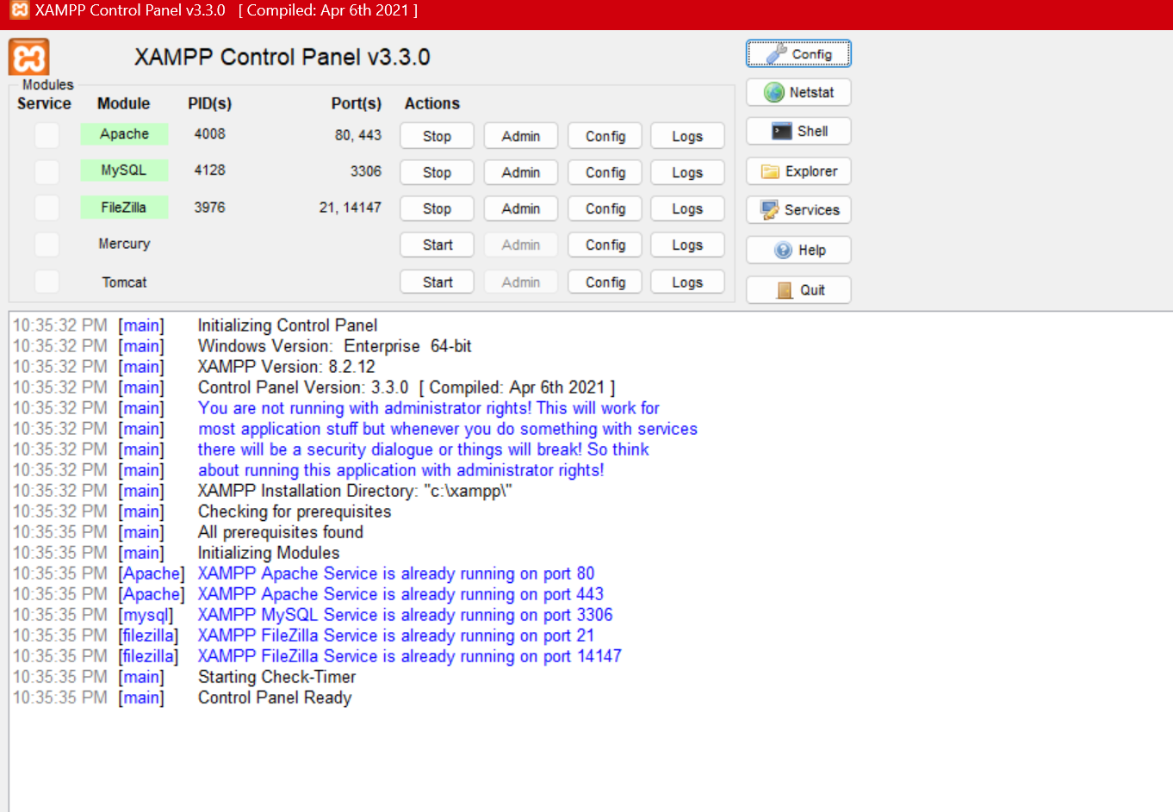

LOCALHOST TESTED SUCCESSFULLY

Figure 1.1: http://localhost/phpmyadmin/
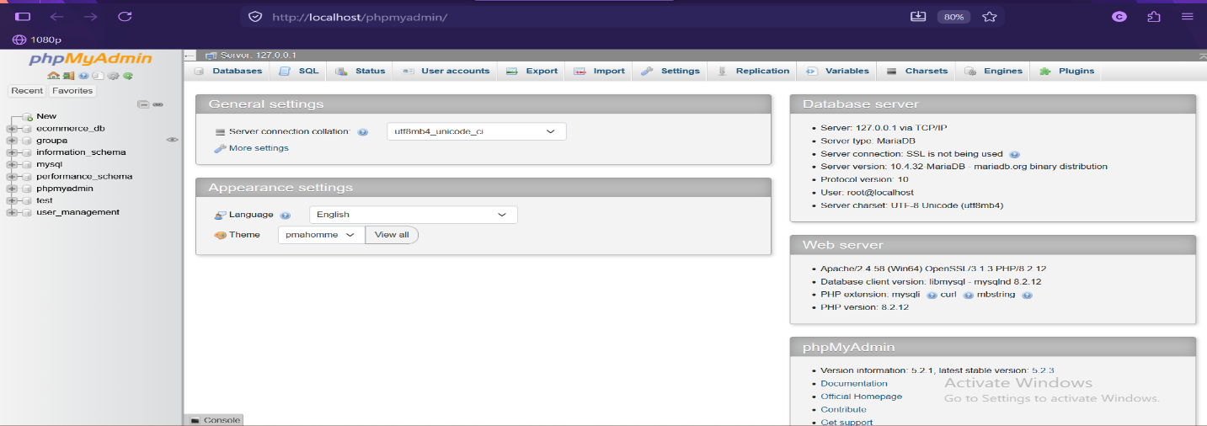

HELLO WORLD PAGE

Figure 1.2: HELLO WORLD Test page
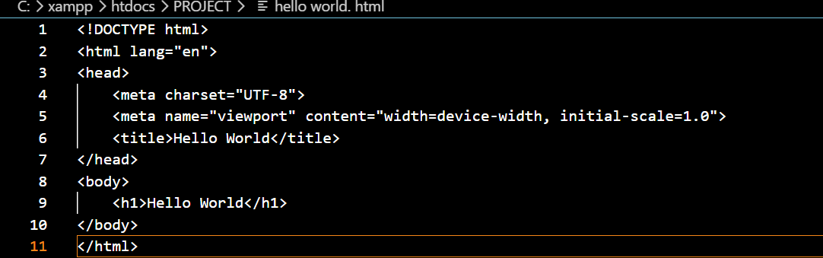


BASIC DATABASE CONNECTIVITY

Figure 1.3.0: sample database
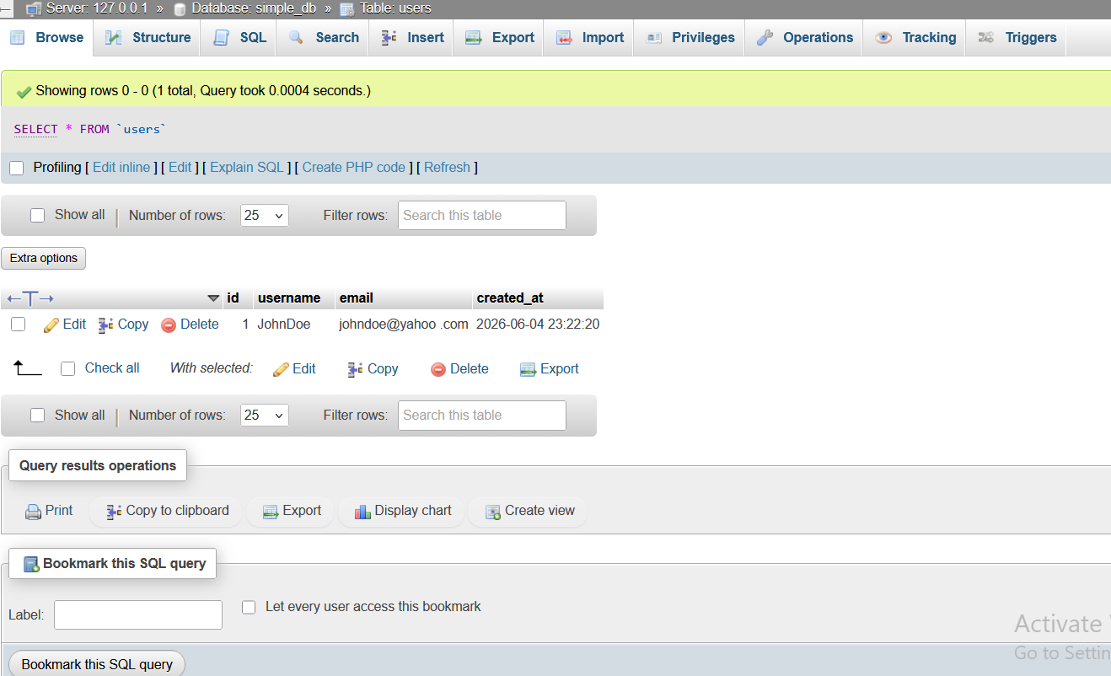

Figure 1.3.1: database connection string
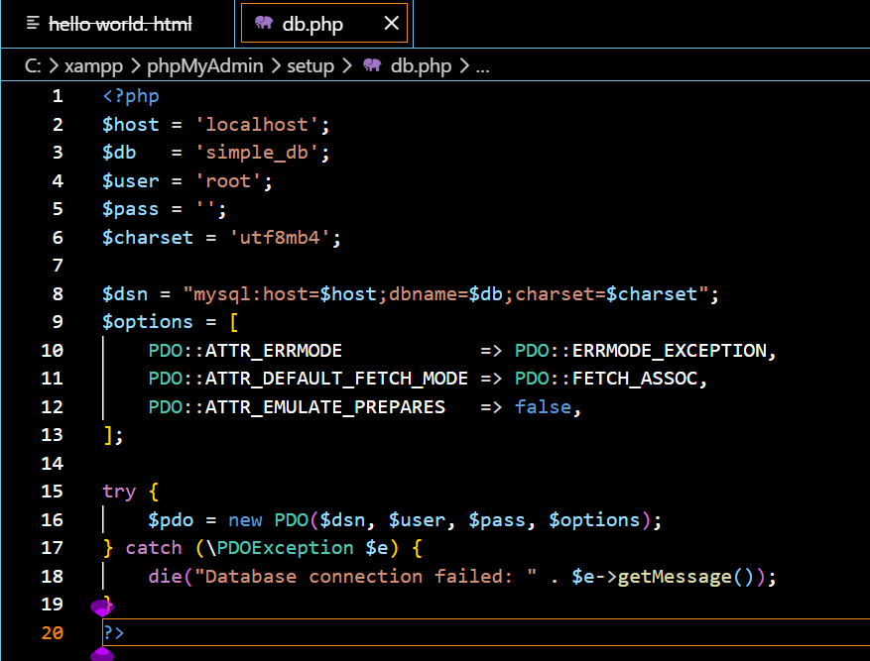

Figure 1.3.2: successful database connection
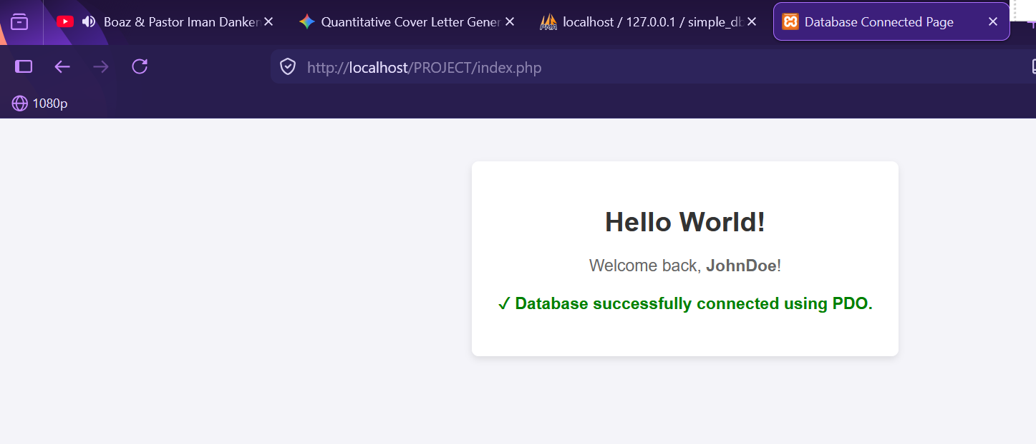

WEEK 2: UI/UX AND DESIGN FOUNDATIONS

DESIGNED WIREFRAMES

Figure 2.0: canva design of the login page
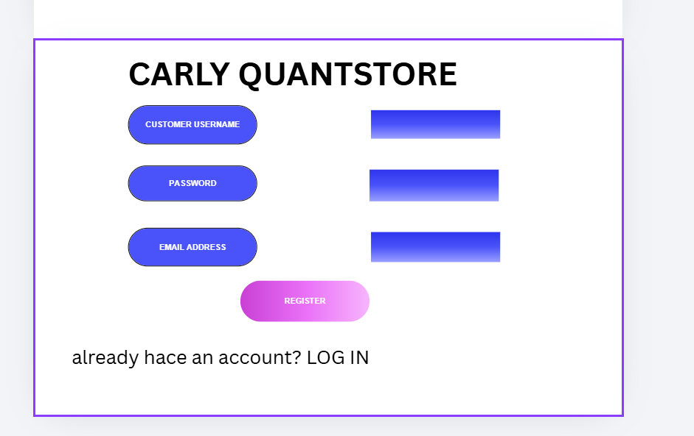

DESIGNED GUI CONCEPTS

Figure 2.1: GUI design
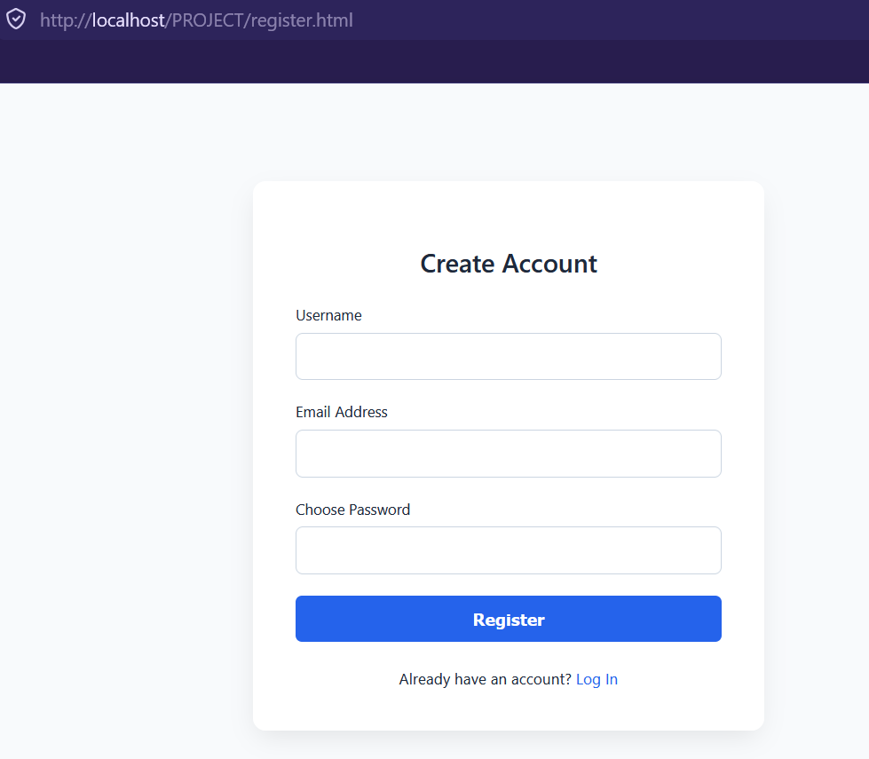

SELECTED PROJECT THEME
I have selected Digital Tech and Gadget Marketplace because tech platforms rely heavily on clean categorization and specification filtering. My MySQL can utilize a structured relational layout to handle precise product attributes. A dynamic product filtering matrix where JavaScript handles search and category filters on the client side by querying your PHP REST API asynchronously.

CHOSEN TECHNOLOGY
For my project I have used PHP, MySQL and Native JavaScript

WEEK 3: FRONTEND AND BACKEND PROGRAMMING FOUNDATION

JavaScript Basics

implemented JavaScript Basics

figure 3.1.0: user implementation
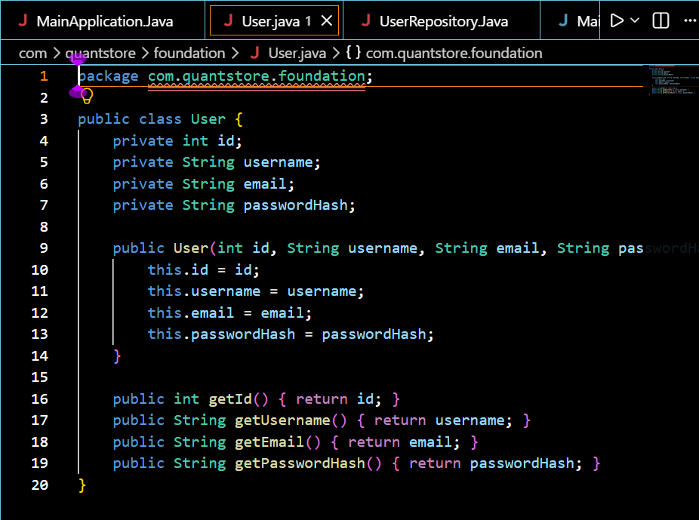

Figure 3.1.1: user repository implementation
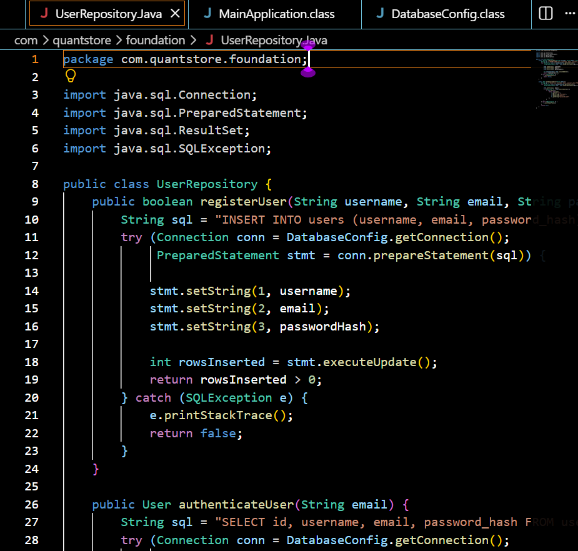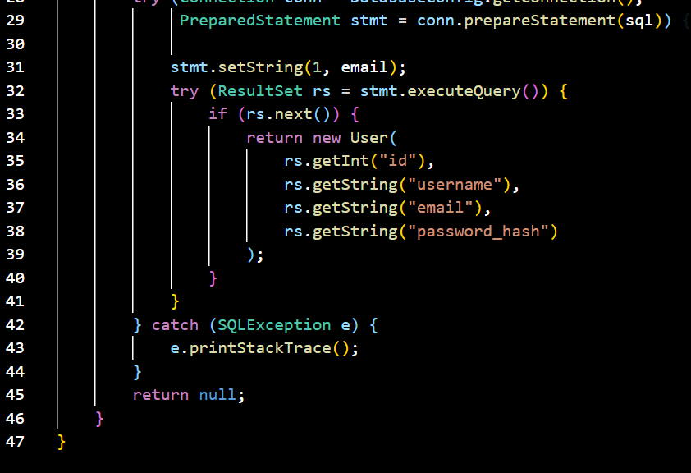

Figure 3.1.2: database configuration implementation
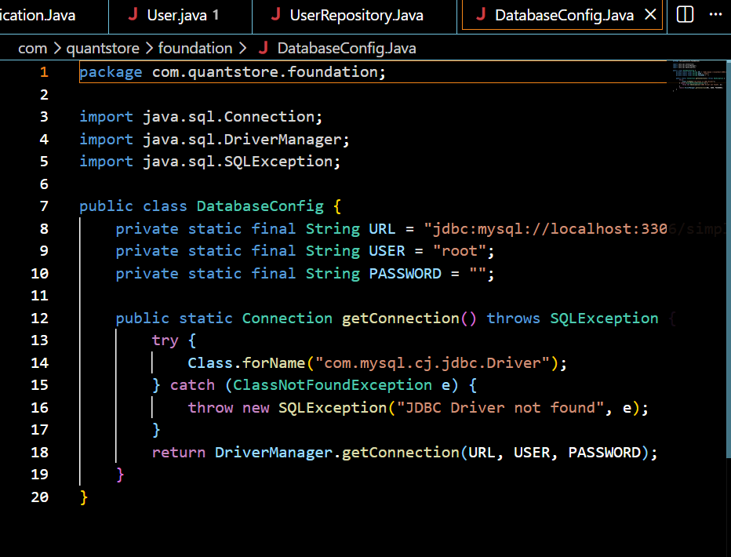

Figure3.1.3: main application java implementation
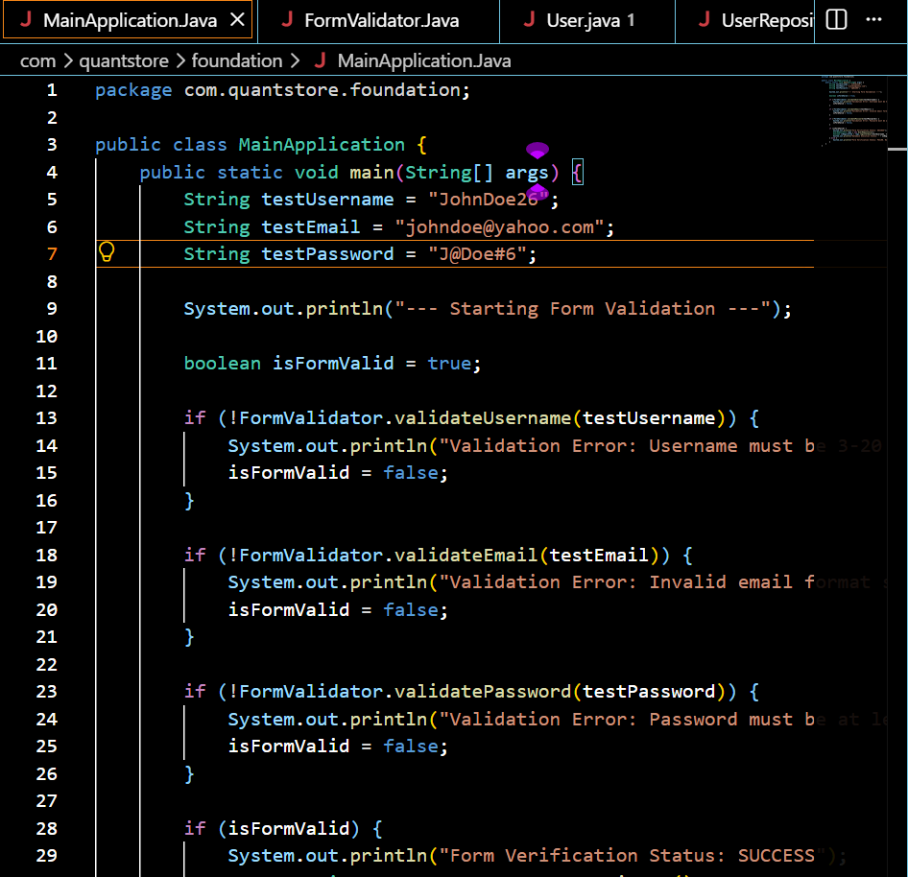
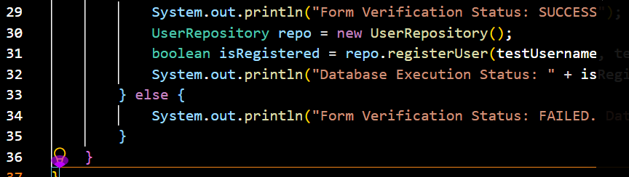

Figure 3.2: Created Form Validation
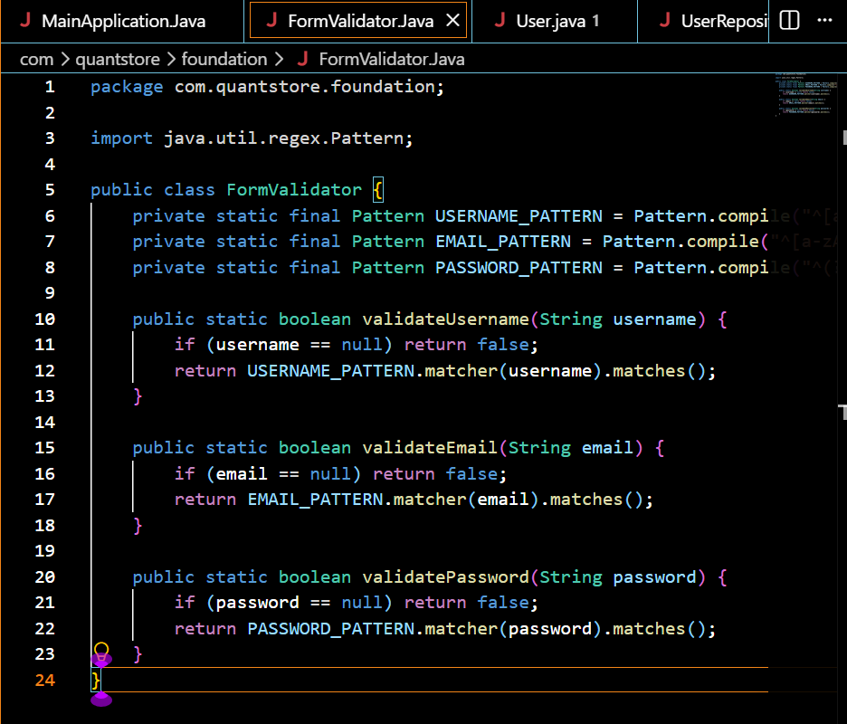

DOM Manipulation

Figure 3.3: successful DOM Manipulation
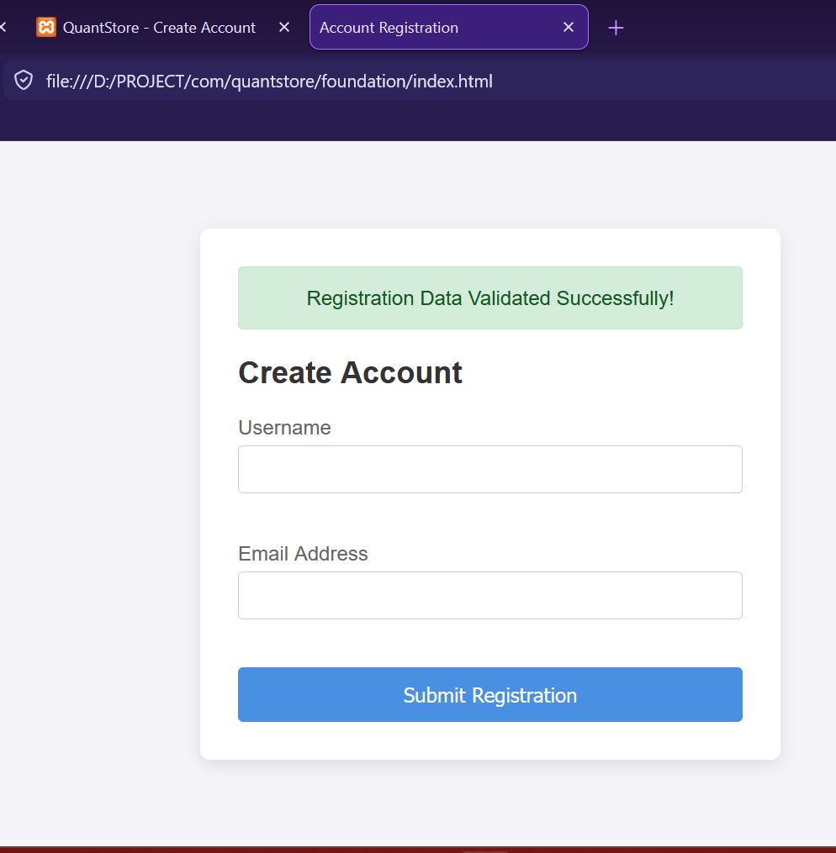

Introduction to PHP

Figure 3.4: Tested PHP Syntax
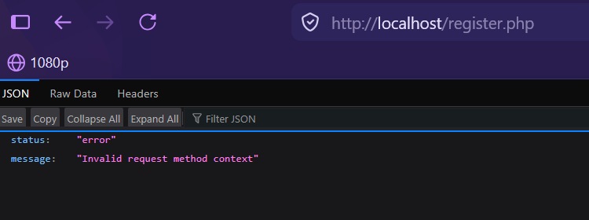

Database Connection

Figure 3.5: Successful Database Connection
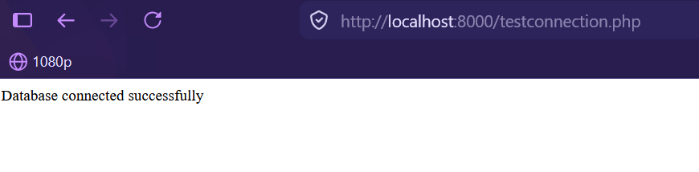

WEEK 4: DYNAMIC BACKEND PROCESSING AND REAL USER INTERACTION SYSTEMS

Login form

Figure 4.0: login form
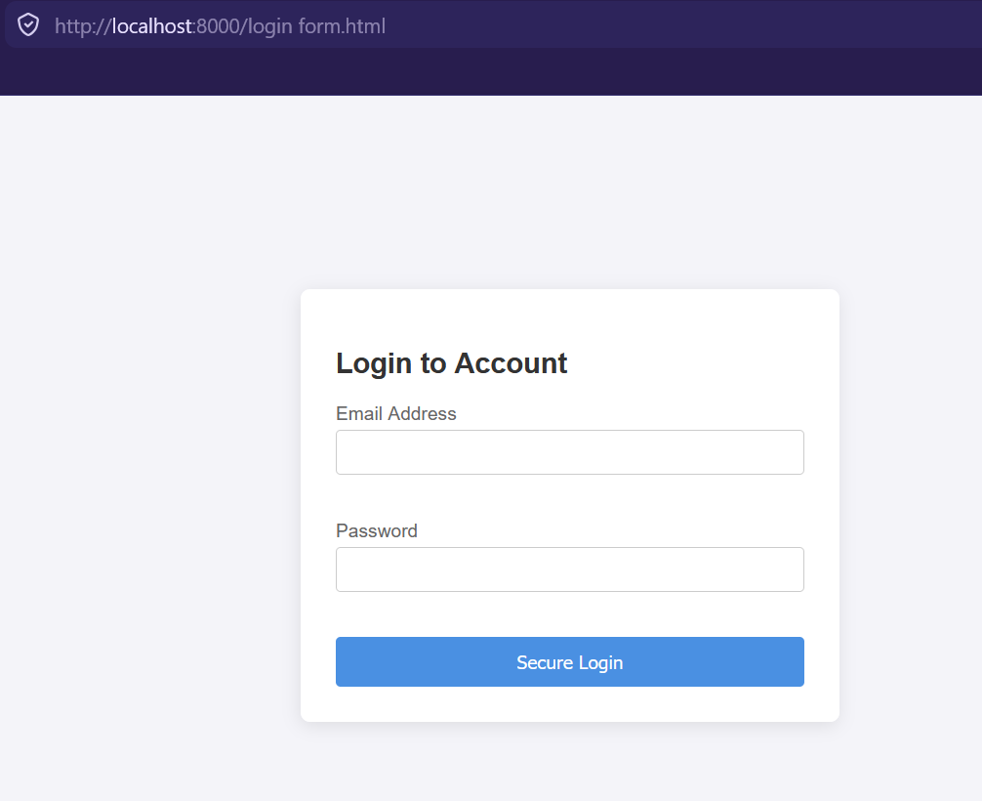

Form validation

Figure 4.1: form validator


PHP processing

Figure 4.2: user authentication processing
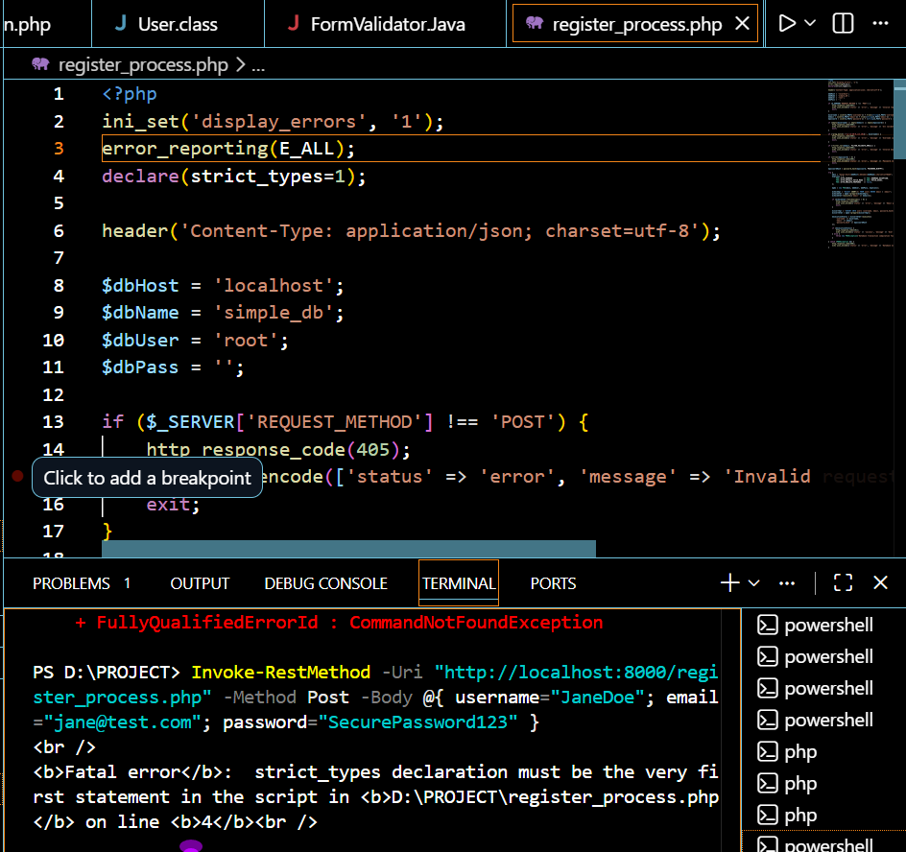

Folder structure

Figure 4.3: folder
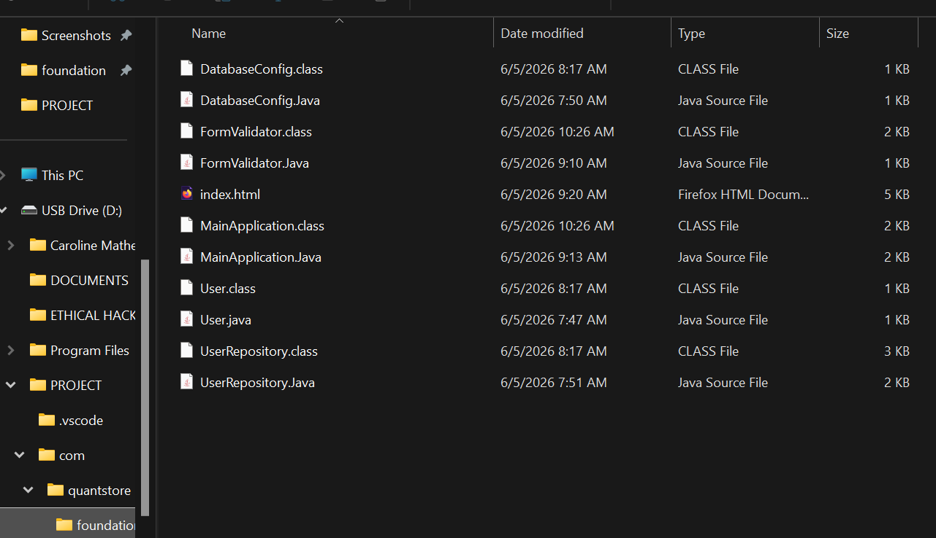

Database connection

Figure 4.4: successful database connection



WEEK 5: BUILDING DATA-DRIVEN SYSTEMS USING DATABASES

DATABASE CREATION

Figure 5.0: creating customer database
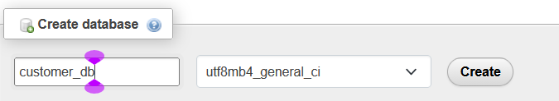

TABLE CREATION THROUGH SQL QUERIES

Figure 5.1: creating customer table
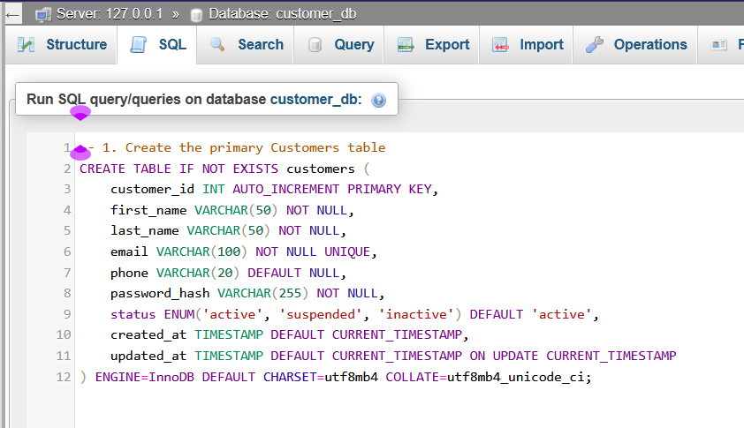
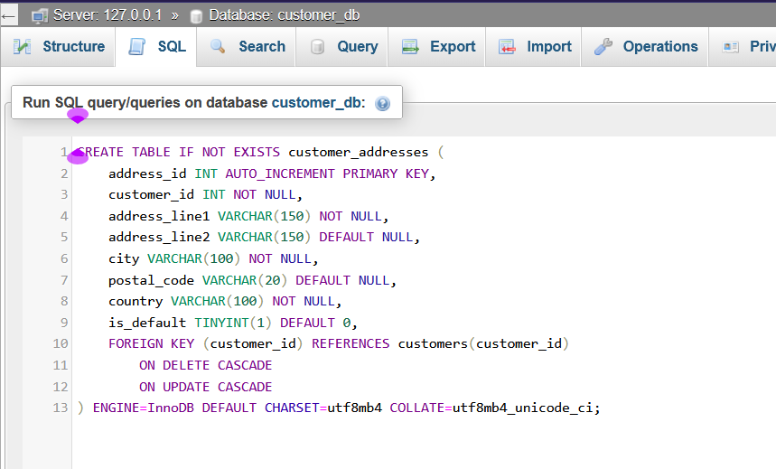

CRUD OPERATIONS

Figure 5.2.0: Create
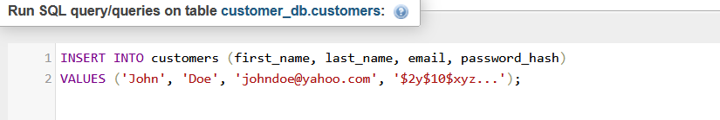

Figure 5.2.1: Read
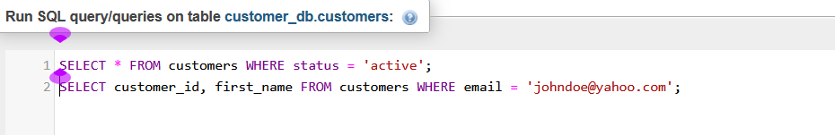

Figure 5.2.2: Update
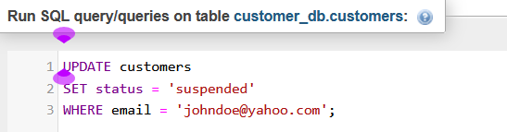

Figure 5.2.3: Delete
